1. Download the ‘Sendasta__Install.xml’ file. This is the settings file that you need to sideload (manually add to Outlook). Download link: <https://cedarace.github.io/Sendasta/sendasta_install.xml>
2. You can now head to the ‘Get Add-ins’ section in Outlook. You can either navigate to ‘Apps’ on the top ribbon bar, then click the + icon. Alternatively, you can navigate directly to <https://aka.ms/olksideload> to get to the ‘Add-ins’ page.

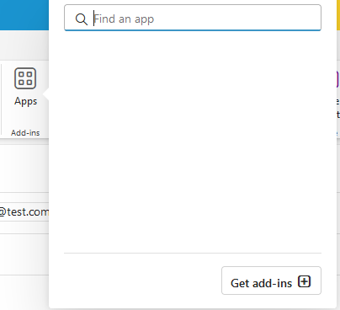

1. On the left-hand side, select ‘My-Add-ins’, then look below at the ‘Custom Add-ins’ section. Click on the + sign, and select ‘Add file’. Navigate to the downloaded Sendasta_Install.xml file that you downloaded earlier. Confirm the prompt to install

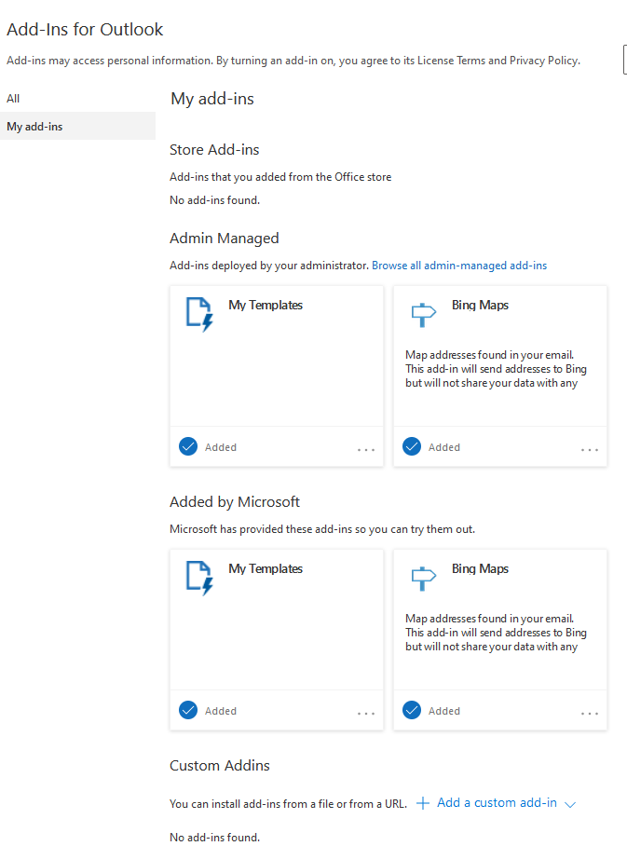

1. To open the ‘settings’ of Sendasta, go to the ‘Apps’ in the Send/Mail section. You can now click on the Sendasta button. This will open a task pane on the right side.
2. You can turn enable or disable Sendasta notifications via this menu. Note that the settings will persists with your user account.

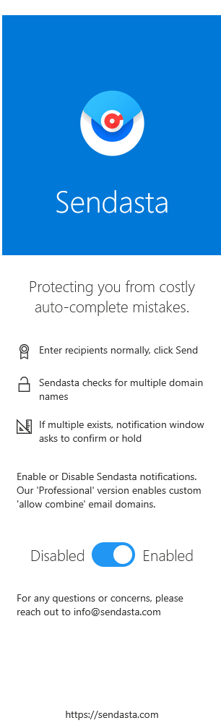

1. Enjoy! Give it a spin, enter two email addresses with different domain names, and watch Sendasta in action.

FAQ:  
- Does it also notify if I include an internal team member? Sendasta will ‘ignore’ different domain names only when the domain names of the sender and the recipient match.

* Can you filter out specific combinations of emails to not have alerts?
* Yes, in our Professional version, an admin-controlled dashboard of lists of domain names to allow or bypass exists.